## **Lesson 17. Тестування API. JSON. REST.**

**Перший рівень**

створи 5 тест-кейсів для функціонального тестування сайту <https://automoto.ua/uk/> (5 найбільш пріоритетних тестів)

| **Section** | **Step Details** | | **Expected Results** | | **Actual Results** | | | **Pass / Fail / Not executed / Suspended** | | |
| --- | --- | --- | --- | --- | --- | --- | --- | --- | --- | --- |
|
| 1. Checking the registration panel | Open the site https://automoto.ua/uk/  1. Click on the button “Sign in to "My Ads" | |  | |  | | | Pass | | |
|  | 2.Enter a valid mobile number | |  | |  | | | Pass | | |
|  | 3.Click on the button “Continue” | | the authorization code is sent to the mobile | | the authorization code is sent to the mobile | | | Pass | | |
|  | 4.Enter the authorization code | |  | |  | | | Pass | | |
|  | 5.Click on the button “Continue” | | User Log in into the system | | User Log in into the system | | | Pass | | |
| 2. Checking the searching panel on the header of the site | Open the site https://automoto.ua/uk/  1. Click on the button “All” | |  | |  | | | Pass | | |
|  | 2. Choose the type of car - passenger | |  | |  | | | Pass | | |
|  | 3. Choose car brand - Audi | |  | |  | | | Pass | | |
|  | 4. Choose model car - A3 | |  | |  | | | Pass | | |
|  | 5. Choose region - Odesa | |  | |  | | | Pass | | |
|  | 6. Mark the Radio Button - state number | |  | |  | | | Pass | | |
|  | 7.Enter price from - 5 | |  | |  | | | Pass | | |
|  | 8.Enter price to | |  | |  | | | Pass | | |
|  | 10.Enter production year from - 2015 | |  | |  | | | Pass | | |
|  | 11. Enter production year to - 2020 | |  | |  | | | Pass | | |
|  | 12. Click on the button “Search” | | All necessary fields filled in . search started | | Search started | | | Pass | | |
| 3.Checking ability to add the car to favorites | Open the site https://automoto.ua/uk/  1.Click on the button “Search” | |  | |  | | | Pass | | |
|  | 2.Choose the car and click on it | | A new window with vehicle information has opened | | A new window with vehicle information has opened | | | Pass | | |
|  | 3. Click on the button “add to the favorites | | the desired product has been added to favorites | | the desired product has been added to favorites | | | Pass | | |
| 4. Checking the possibility of cleaning the list of favorites | Open the site https://automoto.ua/uk/  1.Click on Favorites list | |  | |  | | | Pass | | |
|  | 2. Click on “Clean” | | Open a new window | | Open a new window | | | Pass | | |
|  | 3. Click on “ Delete” | | the list of favorites was cleaned | | the list of favorites was cleaned | | | Pass | | |
| 5. Checking the possibility to add a new announcement | Open the site https://automoto.ua/uk/  1. Click on “My announcement” | |  | |  | | | Pass | | |
|  | 2. Paste in the field for link required link with announcement | | a new ad has been added | | a new ad has been added | | | Pass | | |
|  |  | |  | |  | | |  | | |

2. За допомогою <https://reqbin.com/> протестуйнаступні методи API [Reqres](https://reqres.in/):

* LIST USERS - була помилка

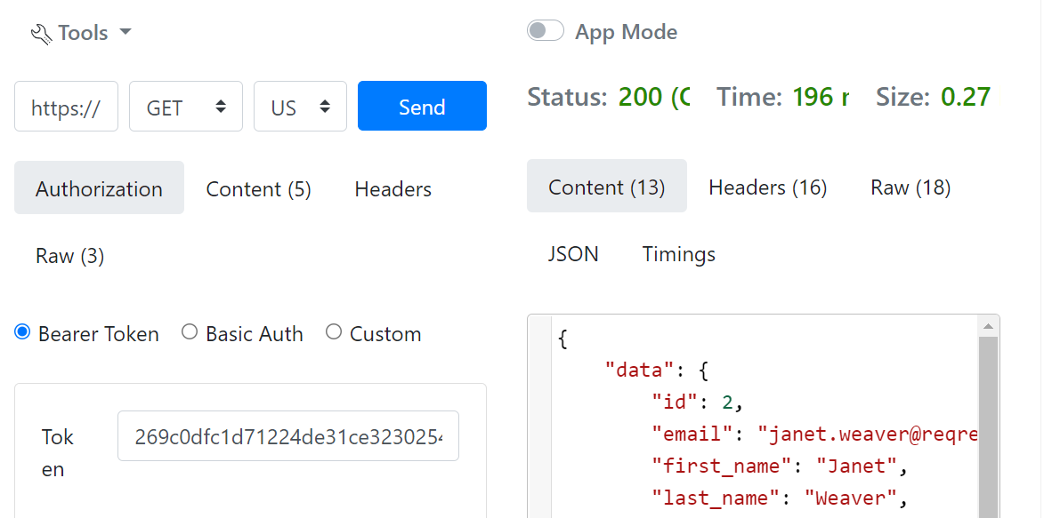

* SINGLE USER

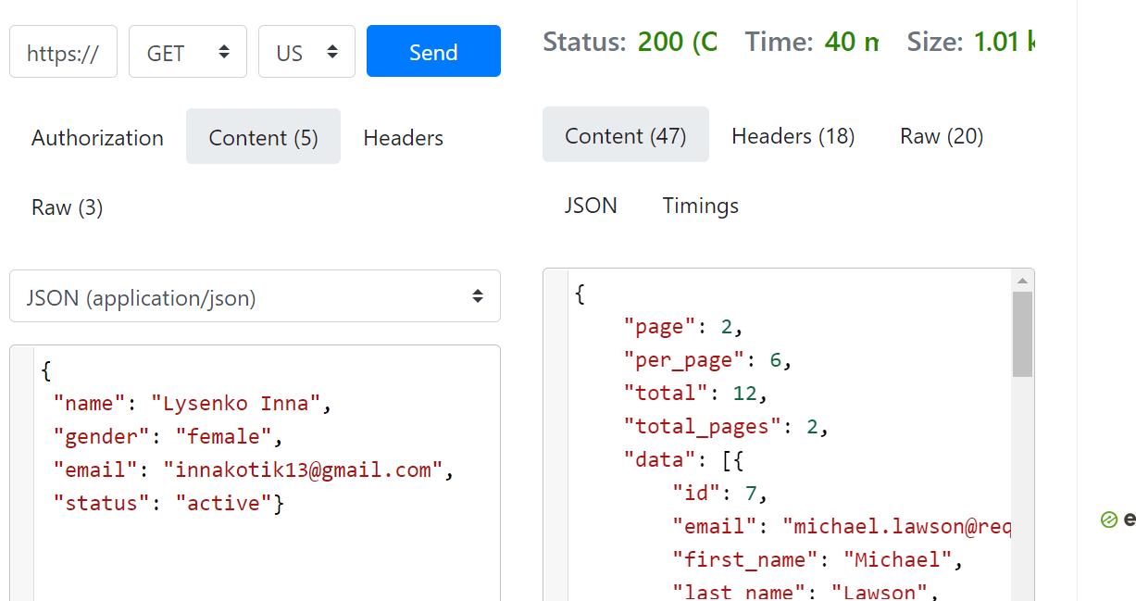

* CREATE

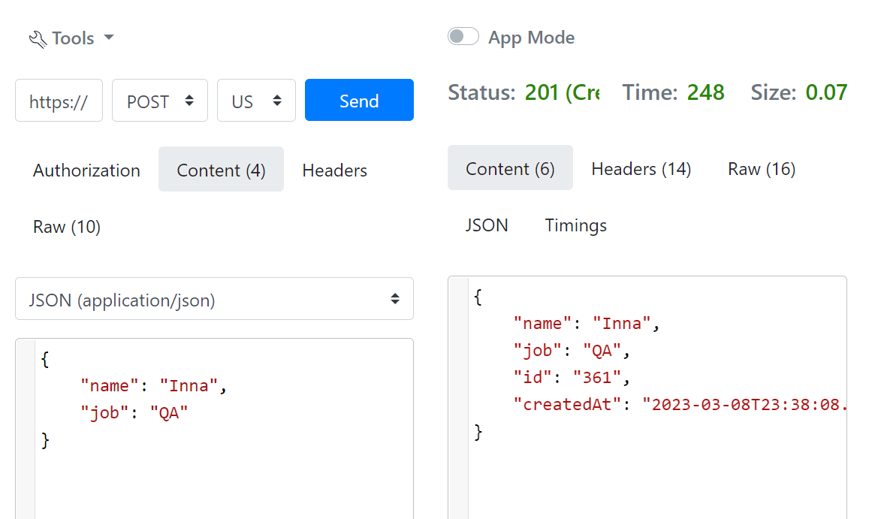

* UPDATE (PUT)

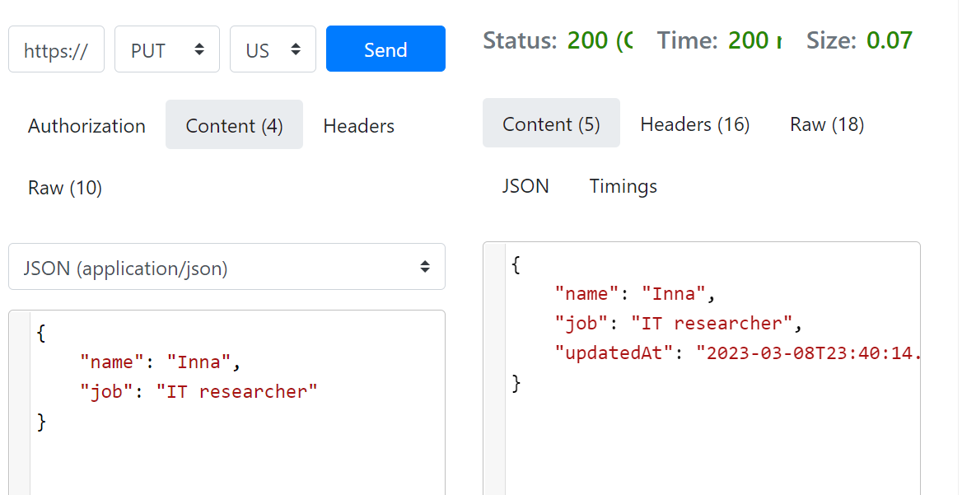

* UPDATE (PATCH)

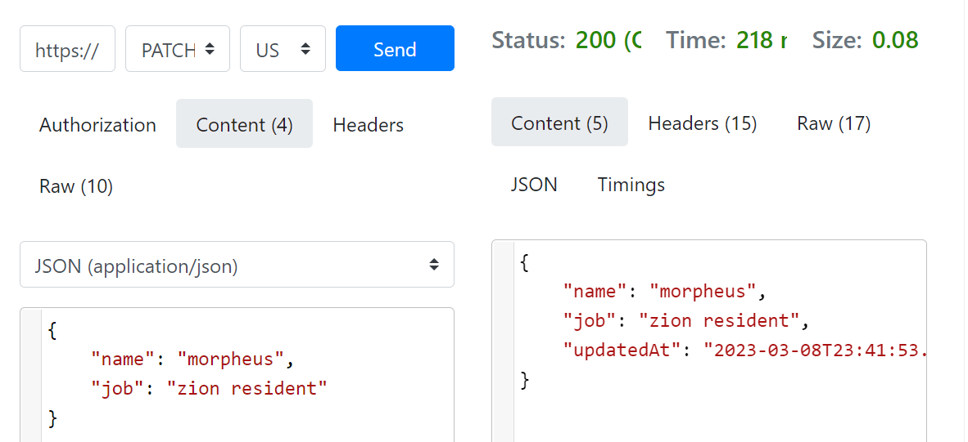

* DELETE

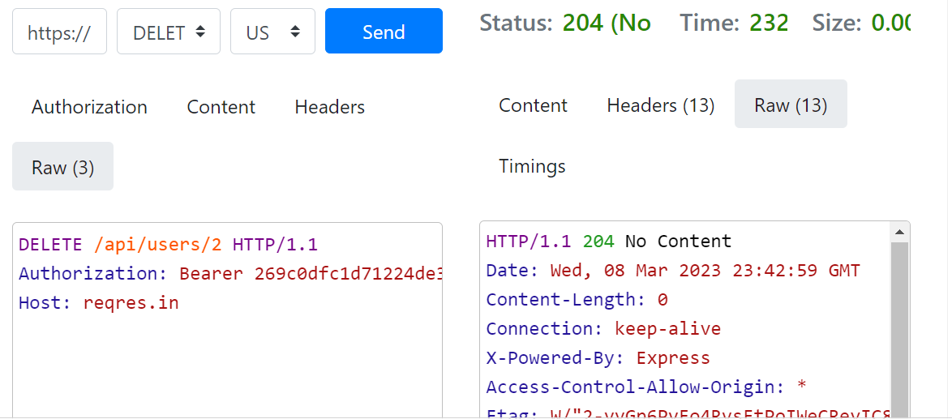

* REGISTER - SUCCESSFUL

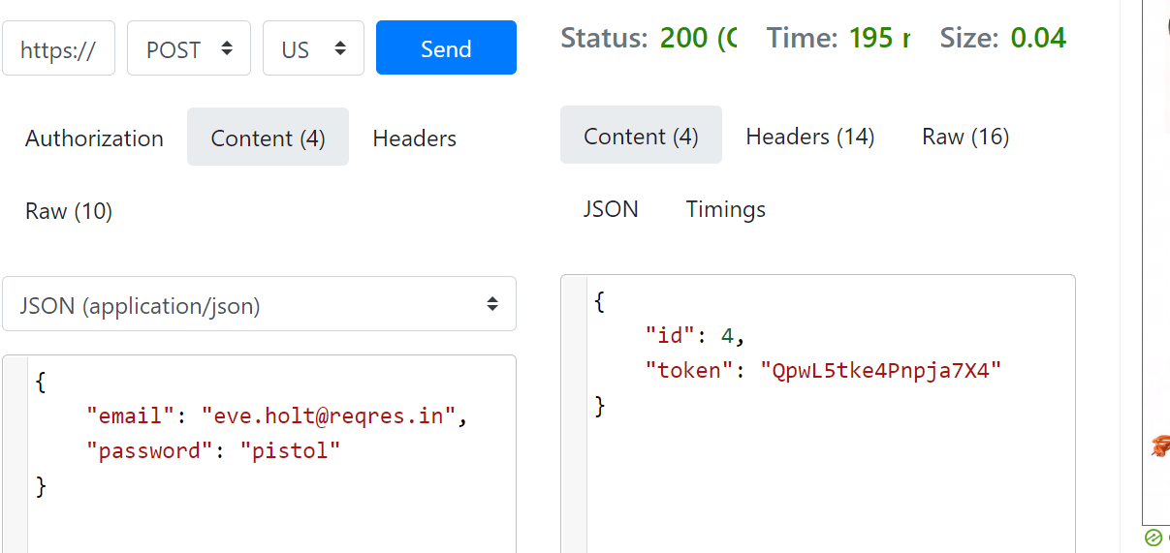

* LOGIN - SUCCESSFUL

